COUNTY: Clallam

Grant Number: SEANWS-2019-ClCoCD-00004

PROJECT TITLE: Forage Fish Summary Report

TASK NUMBER: 2.14

PERIOD COVERED: October 1, 2020 – September 30, 2021

DATE SUBMITTED: September 30, 202

|  |  |
| --- | --- |
| J:\nr A through M\MarineResCom\0. 2015-present\Logos\CCMRC logo no white.jpg | C:\Users\shor461\AppData\Local\Microsoft\Windows\INetCache\Content.Word\PSP-logo-rgb.jpg |
| C:\Users\shor461\AppData\Local\Microsoft\Windows\INetCache\Content.Word\NWSI_logo.png | C:\Users\shor461\AppData\Local\Microsoft\Windows\INetCache\Content.Word\EPA.jpg |

This project has been funded wholly or in part by the United States Environmental Protection Agency. The contents of this document do not necessarily reflect the views and policies of the Environmental Protection Agency under Assistance Agreement [CE-01J65401]. The contents of this document do not necessarily reflect the views and policies of the Environmental Protection Agency, nor does mention of trade names or commercial products constitute endorsement or recommendation for use.

**Forage Fish Surveys**

**Introduction**

In 2016 Clallam MRC joined the Northwest Straits Commission's forage fish monitoring efforts. Three Clallam MRC members and the project coordinator participated in a day long training provided by Washington Department of Fish and Wildlife (WDFW). Between October 2016 and March 2018 Clallam MRC conducted monthly surveys at two locations - Pitship Point adjacent to John Wayne Marina and at a public beach near Old Town east of Dungeness River. In April 2018 the sampling efforts were discontinued at these two sites and sampling was initiated at Cline Spit. Since then monthly sampling has taken place at Cline Spit with one exception in April 2020 which was caused by the Covid-19 Stay-at-Home order. These three sites are considered index sites by WDFW (Figure 1).

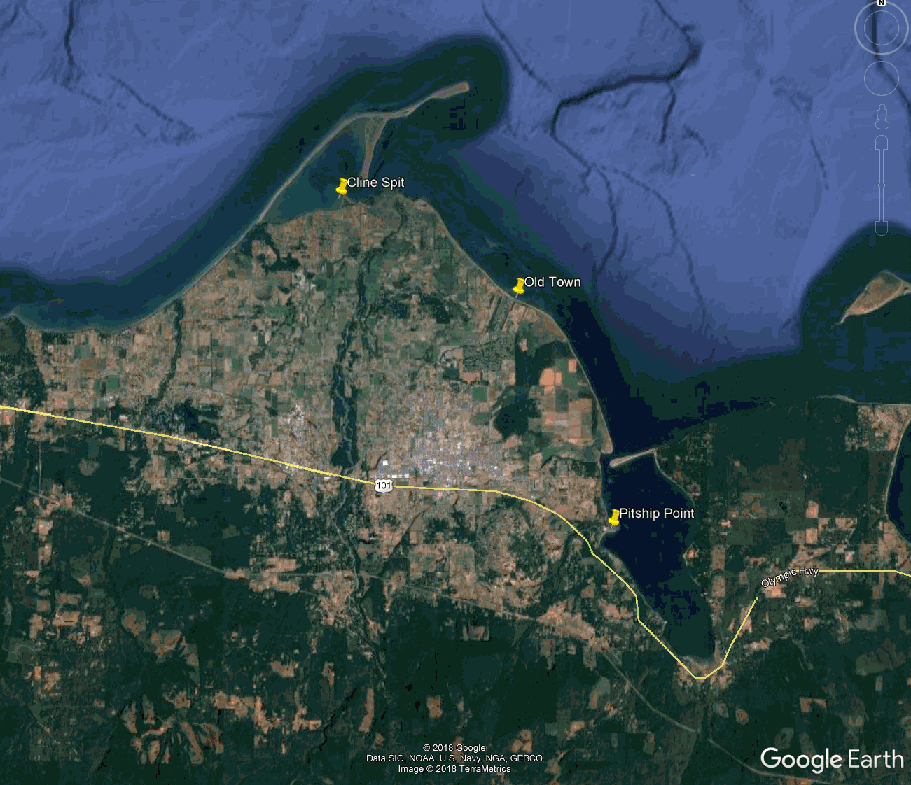

**Figure 1**. Locations of the current index site, Cline Spit, and the two old index sites, Old Town and Pitship. Yellow site is active and green sites are inactive.

In April 2017 the sampling effort was expanded to include monthly sampling at two sites on Ediz Hook. The sites were selected by the Lower Elwha Tribe in an effort to document forage fish spawning in the newly restored area along the inside of the spit. Since sampling commenced the sediment along the inside of the spit has coarsened and as a result the sampling locations have been moved progressively further to the west (Figure 2). During the 2018 fall and winter months (October through March) the sampling effort on Ediz Hook was discontinued because of Lower Elwha tribe staffing limitation. The effort was restarted in April 2019 and sampling was carried out at the West Rowing Club and Tesoro Beach sites monthly except for October 2019 and April 2020. Sampling was not conducted in October because of Lower Elwha tribe staff limitation and in April 2020 because of Covid-19 Stay-at-Home order.

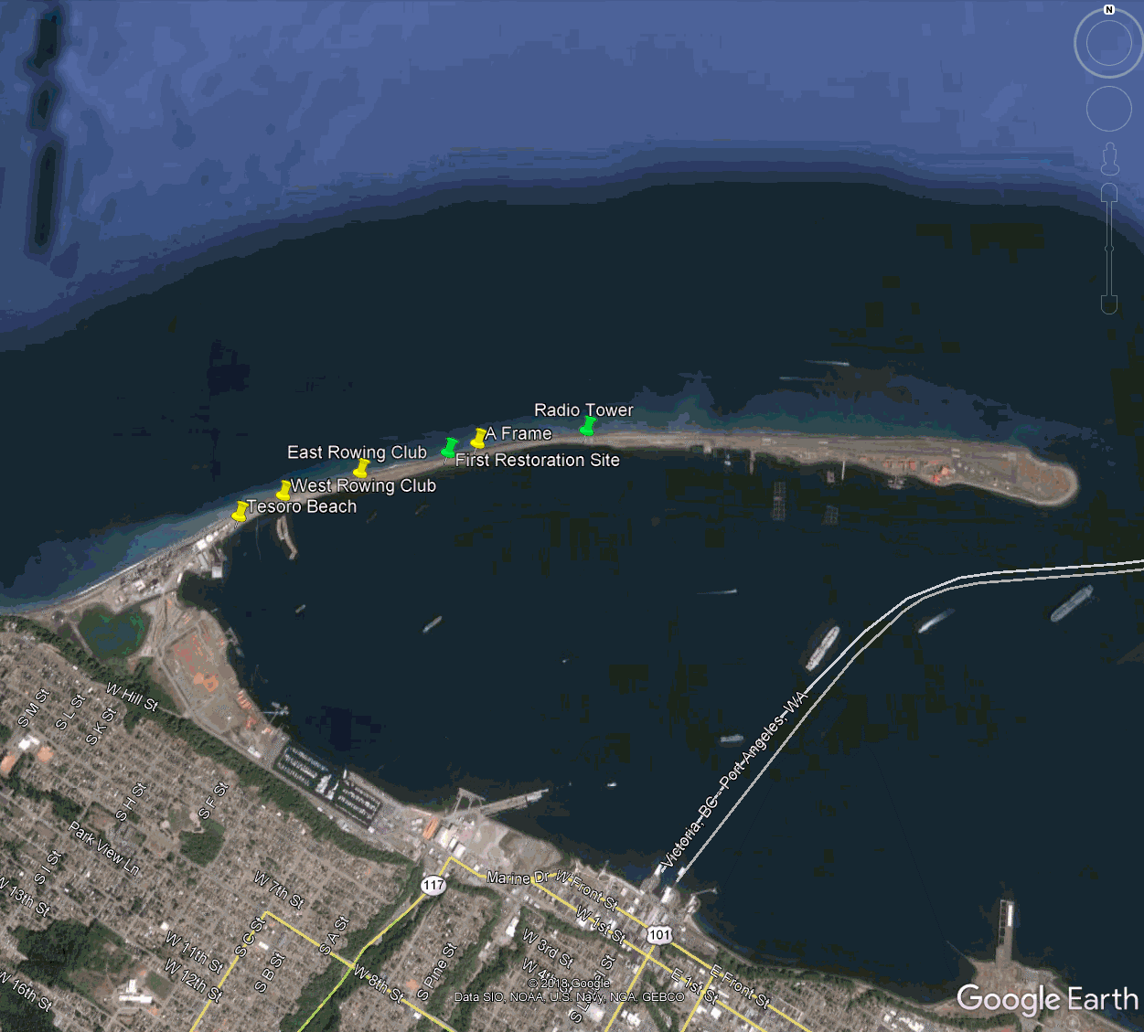

**Figure 2**. Sampling locations on Ediz Hook, 2017-20. Yellow sites are active and green sites are inactive (Google Earth map).

In previous years forage fish sampling has been conducted at two sites on the beach east of the Elwha River mouth. Due to staff limited staff time one site has been initiated again on newly restored Elwha beach east of the Elwha River mouth starting in July 2021. Due to the size of this beach we have been choosing sampling site at random on the beach in hopes to find eggs. If eggs are found then we will use that site sample site.

The samples are analyzed for fish eggs at the WDFW laboratory. Because the samples are preserved in Stockard solution they cannot be shipped directly to the laboratory in Olympia. Instead the samples are hand delivered to Lucas Hart, Director of Northwest Straits Commission, in Port Hadlock. Lucas takes the samples to the WDFW office in Port Townsend (only open during workdays between 8 am and 4 pm) and WDFW staff delivers the samples to the laboratory. Because of the long delivery chain it takes a long time for the samples to reach the laboratory. The last sample received by the laboratory was collected in October 2019. When Covid-19 restrictions were enforced samples collected between November 2019 and March 2020 were in transit to the laboratory. All samples collected after April 2020 were stored at Clallam MRC waiting for the reopening of the WDFW laboratory. In early August the NWSC and Clallam MRC received notice that the laboratory had reopened and the delivery chain was reinitiated.

**Results**

The WDFW conducts the laboratory analysis of most of the samples collected by all the participating MRCs. Clallam MRC collected 28 samples in 2020-21. Table 1 summarizes the results of these samples. A high number of surf smelt eggs were found in the samples collected at Cline Spit in January and April 2021 and few Rock sole were found in one sample collected at Tesoro Beach on Ediz Hook. Photos taken during the sampling days at the sites are shown in Figure 3.

**Figure 3.** Photos taken on the sampling days at the index site and the two restoration sites.

|  |  |
| --- | --- |
| J:\nr A through M\MarineResCom\0. 2015-present\2016-20 Forage Fish\Surveys\37. Oct. 2019 Survey\small\Photo D Cline Spit 10-11-19.jpg | J:\nr A through M\MarineResCom\0. 2015-present\2016-20 Forage Fish\Surveys\37. Oct. 2019 Survey\small\Photo F Cline Spit 10-11-19.jpg |
| October 11 , 2019 Index Site: Cline Spit |  |
| J:\nr A through M\MarineResCom\0. 2015-present\2016-20 Forage Fish\Surveys\41. Feb 2020 Surveys\Ediz Hook\W Row Club\Photo D W. Row Club 2-20-20.jpg | J:\nr A through M\MarineResCom\0. 2015-present\2016-20 Forage Fish\Surveys\41. Feb 2020 Surveys\Ediz Hook\W Row Club\Photo F W. Row Club 2-20-20.jpg |
| February 2, 2020 Restoration Site: Ediz Hook West of Rowing Club | |
| J:\nr A through M\MarineResCom\0. 2015-present\2016-20 Forage Fish\Surveys\41. Feb 2020 Surveys\Ediz Hook\Tesoro Beach\Photo E Tesoro Beach 2-20-20.jpg | J:\nr A through M\MarineResCom\0. 2015-present\2016-20 Forage Fish\Surveys\41. Feb 2020 Surveys\Ediz Hook\Tesoro Beach\Photo F Tesoro Beach 2-20-20.jpg |
| February 2, 2020 Restoration Site: Ediz Hook at Tesoro Beach | |

| **Table 1. Summary of WDFW laboratory analysis and database information on samples collected by Clallam MRC members and volunteers** | | | | | | | | | | | |
| --- | --- | --- | --- | --- | --- | --- | --- | --- | --- | --- | --- |
| **Survey Date** | **Location** | **Beach Station** | **Sample** | **Field Sheet** | **Lab Sheet Sample** | **Photos** | **WDFW QAQC** | **Surf Smelt** | **Sand Lance** | **Rock Sole** | **Comments** |
| 10/28/2020 | Cline Spit | 1 | 1 | Y | Y | Y | Y | 663 | 0 | 0 |  |
| 10/15/2020 | Ediz Hook | 1 | 1 | Y | Y | Y | Y | 3 | 0 | 0 | W Row Club |
| 10/15/2020 | Ediz Hook | 2 | 1 | Y | Y | Y | Y | 0 | 0 | 0 | Tesoro Beach |
| 11/10/2020 | Cline Spit | 1 | 1 | Y | Y | Y | Y | 0 | 0 | 0 | photos taken on 11/11 because it was too dark on 11/10 |
| 11/11/2020 | Ediz Hook | 1 | 1 | Y | Y | Y | Y | 2 | 0 | 0 | W Row Club |
| 11/11/2020 | Ediz Hook | 1 | 1 | Y | Y | Y |  | | | | Tesoro Beach |
| 12/11/2020 | Cline Spit | 1 | 1 | Y | Y | Y |  | | | |  |
| 12/9/2020 | Ediz Hook | 1 | 1 | Y | Y | Y | W Row Club |
| 12/9/2020 | Ediz Hook | 1 | 1 | Y | Y | Y | Tesoro Beach |
| 1/21/2021 | Ediz Hook | 1 | 1 | Y | Y | Y | W Row Club |
| 1/21/2021 | Ediz Hook | 1 | 1 | Y | Y | Y | Tesoro Beach |
| 1/22/2021 | Cline Spit | 1 | 1 | Y | Y | Y |  |
| 2/22/2021 | Ediz Hook | 1 | 1 | Y | Y | Y | W Row Club |
| 2/22/2021 | Ediz Hook | 1 | 1 | Y | Y | Y | Tesoro Beach |
| 2/19/2021 | Cline Spit | 1 | 1 | Y | Y | Y | sample jar said 2/18, iForm said 2/19. Belive 2/19 to be correct since iForm is autofill. |
| 3/17/2021 | Ediz Hook | 1 | 1 | Y | Y | Y | W Row Club |
| 3/17/2021 | Ediz Hook | 1 | 1 | Y | Y | Y | Tesoro Beach |
| 3/16/2021 | Cline Spit | 1 | 1 | Y | Y | Y |  |
| 4/20/2021 | Ediz Hook | 1 | 1 | Y | Y | Y | sample lost, W Row Club |
| 4/20/2021 | Ediz Hook | 1 | 1 | Y | Y | Y | Tesoro Beach |
| 4/19/2021 | Cline Spit | 1 | 1 | Y | Y | Y |  |
| 5/21/2021 | Ediz Hook | 1 | 1 | Y | Y | Y | W Row Club |
| 5/21/2021 | Ediz Hook | 1 | 1 | Y | Y | Y | Tesoro Beach |
| 5/18/2021 | Cline Spit | 1 | 1 | Y | Y | Y |  |
| 6/9/2021 | Cline Spit | 1 | 1 | Y | Y | Y |  |
| 6/10/2021 | Ediz Hook | 1 | 1 | Y | Y | Y | W Row Club |
| 6/10/2021 | Ediz Hook | 1 | 1 | Y | Y | Y | Tesoro Beach |
| 7/14/2021 | Cline Spit | 1 | 1 | Y | Y | Y |  |
| 7/14/2021 | Ediz Hook | 1 | 1 | Y | Y | Y |  | | | | Tesoro Beach |
| 7/14/2021 | Elwha Beach | 1 | 1 | Y | Y | Y |  |